Project Design Phase-I
Solution Architecture

Date | 1 November 2026
Team ID
Project Name | Electric Vehicle Market Performance & Insights
Maximum Marks | 4 Marks

Solution Architecture:
Solution architecture is a complex process – with many sub-processes – that bridges the gap between business problems and technology solutions. Its goals are to:
- Find the best tech solution to solve existing business problems.
- Describe the structure, characteristics, behavior, and other aspects of the software to project stakeholders.
- Define features, development phases, and solution requirements.
- Provide specifications according to which the solution is defined, managed, and delivered.

Sample Solution Architecture Diagram:
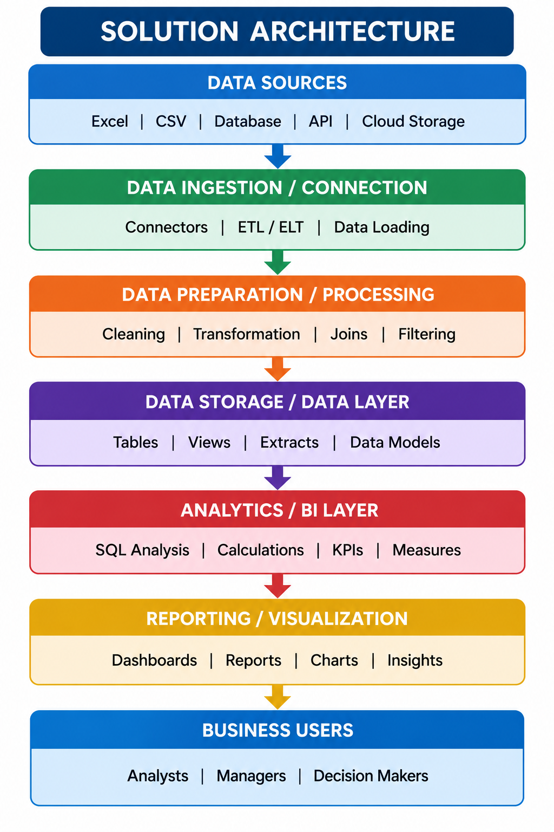

Component Description Table
Component Name | Description / Role in Architecture | Technology Used

EV Market Analysis – Solution Architecture
Architecture flow (logical view):
Architecture layer | Role / data flow
1. DATA SOURCE | Supplied EV dataset (vehicle, manufacturer, year, category, battery, price, range, ratings, CO₂ and country fields)
2. DATA INGESTION | Import/connect the dataset in Tableau
3. DATA PREPARATION | Review field types and data quality; prepare dimensions and measures for analysis
4. ANALYTICS LAYER | Aggregate sales, average range, average price, customer ratings, battery counts/distribution and CO₂ savings
5. VISUALIZATION LAYER | Build eight Tableau worksheets and assemble them into one dashboard
6. PUBLISHING | Publish dashboard to Tableau Public
7. BUSINESS USERS | EV buyers, market researchers, analysts and business stakeholders view and interpret the dashboard

Component Description Table
Component name | Description / role in architecture | Technology used
EV dataset | Source records used for all dashboard calculations and views. | Supplied structured dataset (exact source/format not provided)
Data connection | Loads the source data into the analytics environment. | Tableau data connection / file import
Data preparation | Ensures fields are usable as dimensions and measures; supports consistent aggregation. | Tableau data preparation and field configuration
Analytics & calculations | Aggregates sales, range, price, ratings, battery distribution and CO₂ savings. | Tableau worksheets and aggregations
Dashboard & visualizations | Presents eight charts and the country map in a consolidated view. | Tableau Desktop
Publishing & access | Makes the dashboard available via a shareable public page. | Tableau Public
Note: This is the logical architecture based on the demonstrated Tableau workflow. No separate database, API, Python pipeline, cloud warehouse or custom web application is assumed.

